HW10 Report

R08525103 尤梓峰

Laplace Mask1 (0, 1, 0, 1, -4, 1, 0, 1, 0): 15

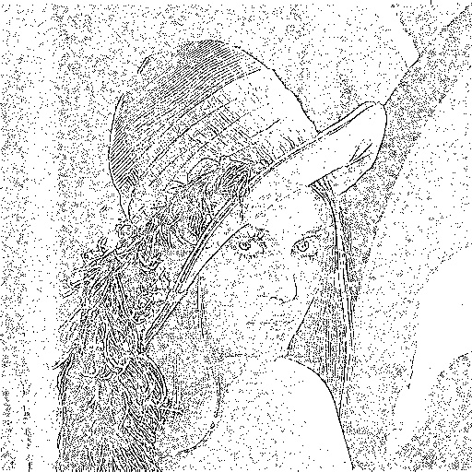

Laplace Mask2 (1, 1, 1, 1, -8, 1, 1, 1, 1):15

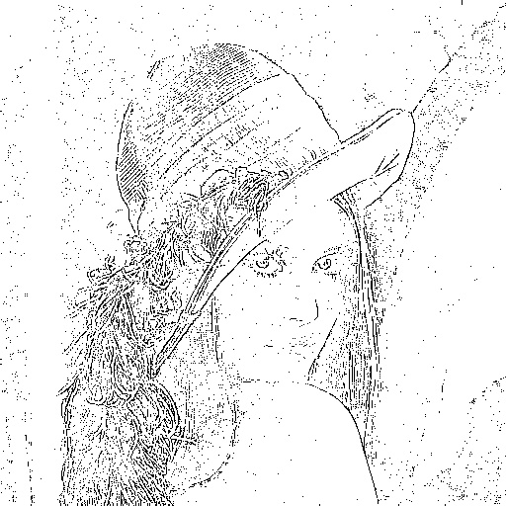

Minimum variance Laplacian: 20

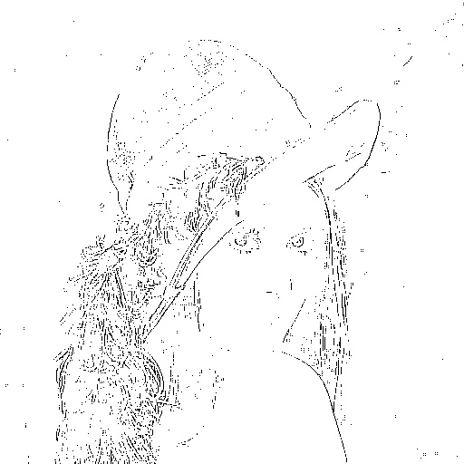

Laplace of Gaussian: 3000

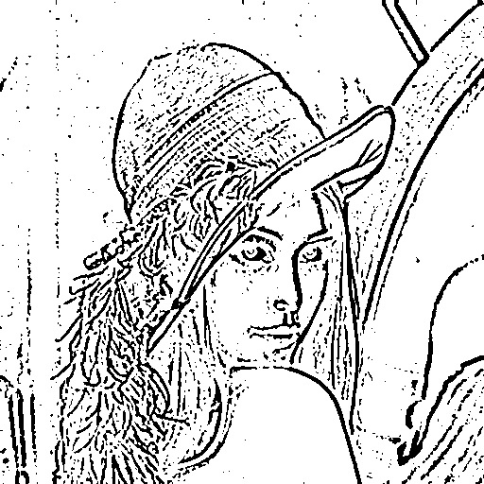

Difference of Gaussian: 1

